Stats Video Lecture – Disjoint Events plus the General Addition Rule

Week 2, Video 1

1. Disjoint Events (Mutually Exclusive)
   1. two events cannot happen at the same time
   2. ex – the outcome of a single coin toss cannot yield both a head and a tail
   3. ex – a single card selected from a deck cannot both be a 2 and a Queen
   4. The probability of events A and B happening concurrently = 0

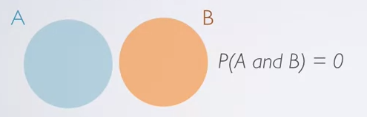

* 1. The Union of disjoint events P(A OR B) = P(A) + P(B)

1. Non-Disjoint Events
   1. two events that can happen at the same time
   2. ex – tossing two coins can result in a head and a tail simultaneously
   3. The probability of events A and B happening concurrently is non zero

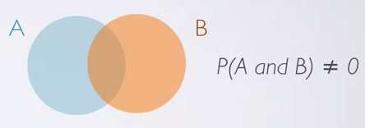

* 1. The Union of non-disjoint events P(A OR B) = P(A) + P(B) – P(A and B)

1. General Addition Rule
   1. Union of any event P(A or B) = P(A) + P(B) – P(A and B)
      1. P(A and B) = 0 if the events are disjoint
2. Sample Space
   1. Collection of all possible outcomes of a trial
      1. ex – what are the possible genders of a couple having two children
3. Probability Distributions – discrete
   1. lists all possible outcomes within a sample space and the probability with which they occur

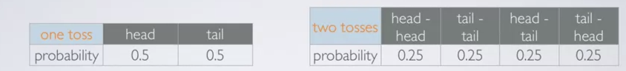

* 1. R1 – the events listed must be disjoint
  2. R2 – each probability must be between 0 and 1
  3. R3- $\sum{p_{x}=1}$

1. Introduction to Complementary Events
   1. two disjoint events whose probabilities equal to 1
   2. the complement of a heads on a coin toss is a tail

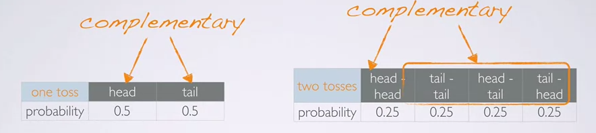

1. Disjoint events vs Complementary Events
   1. Do the sum of probabilities of two disjoint outcomes always add up to one?
      1. no, there may be more than 2 outcomes in the sample space
   2. Do the sum of probabilities of two complementary outcomes always add up to one?
      1. yes, that is the definition of complementary
   3. Ergo, complementary events are always disjoint, but disjoint events are not always complementary